Assignment 11.4

Task-1:

1. Code skeleton with **Google-style docstrings**
2. Sample **test code** for stack operations
3. Suggested **optimizations and alternatives**

**1. Stack Class in Python (Using List)**

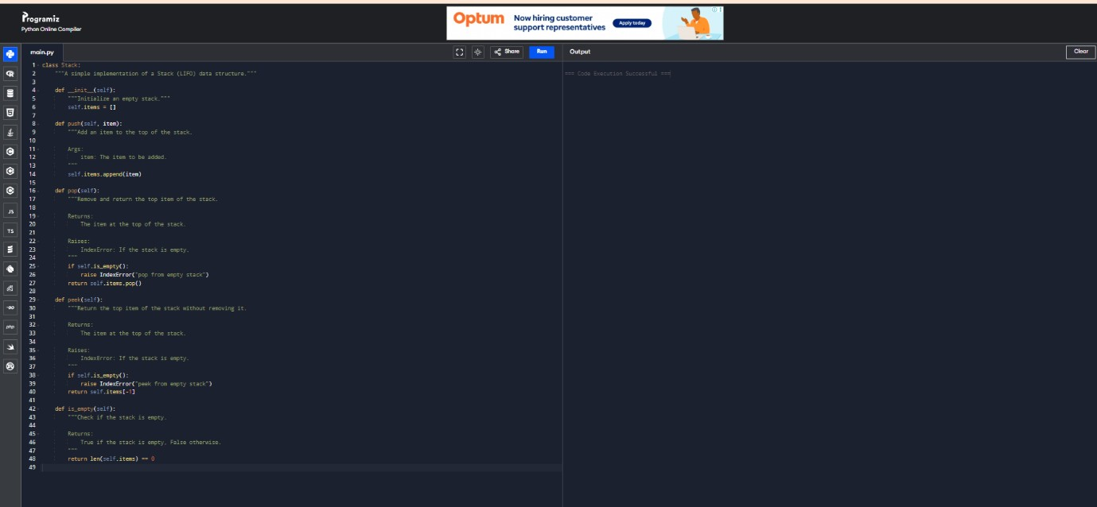

2.Sample **test code** for stack operations

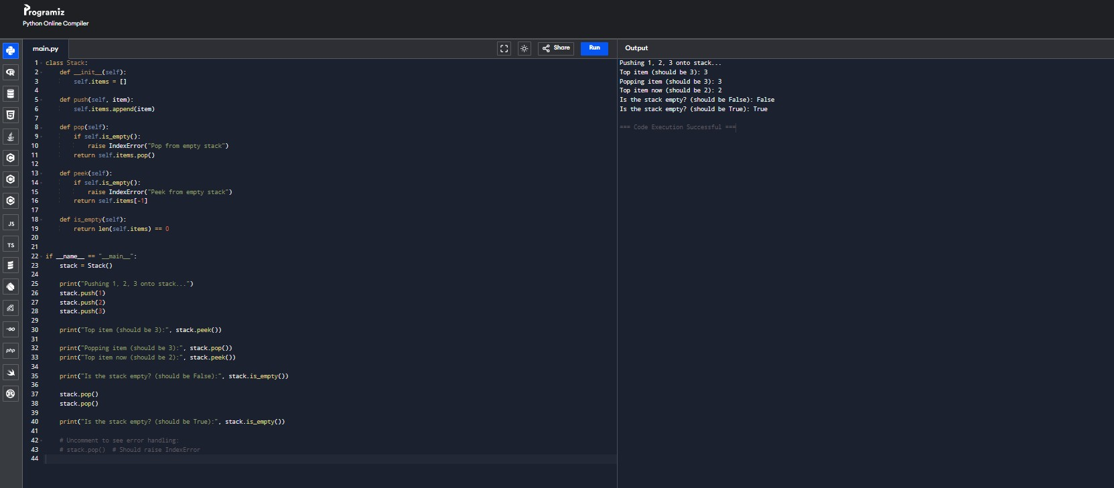

3. Suggested **optimizations and alternatives**

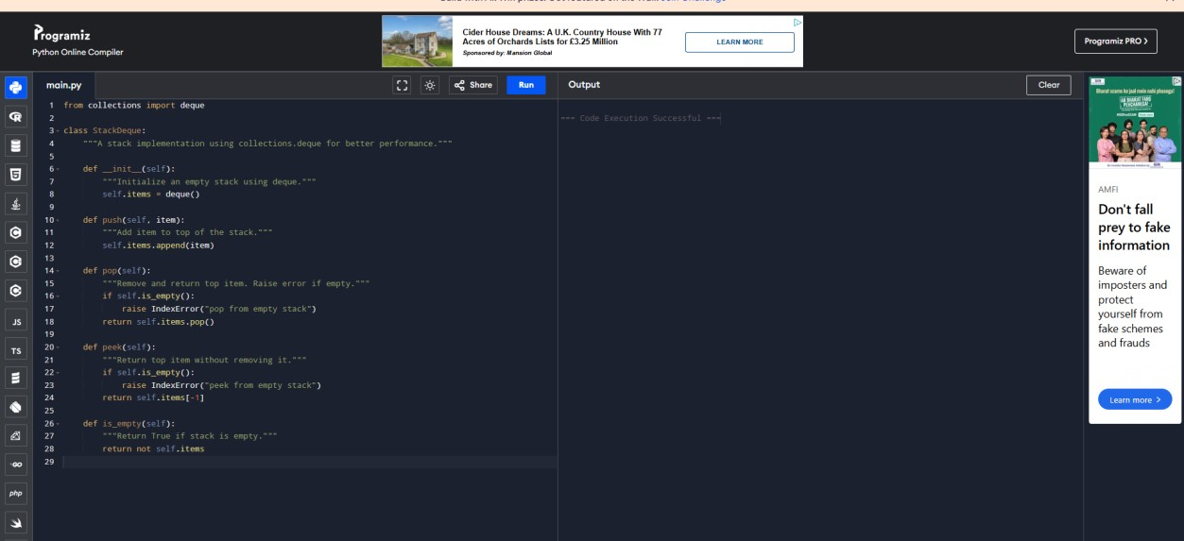

Task -2:

1.Queue python coding

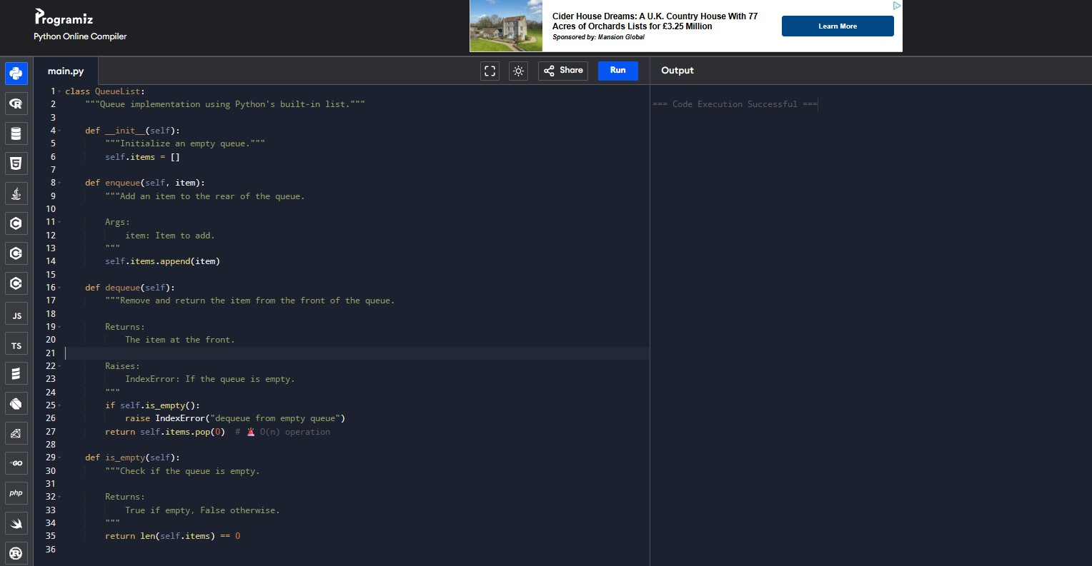

2.optimized python coding

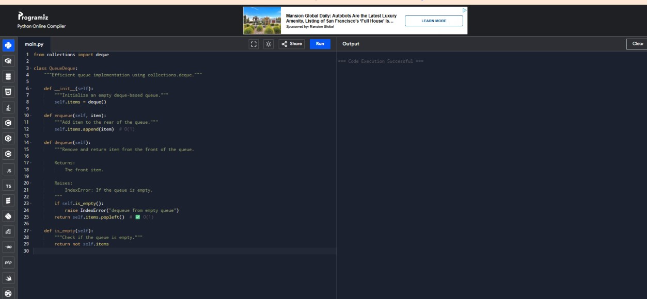

3.

**Qu~~eu~~eDeq~~ue~~**

**Qu~~eu~~eLis**

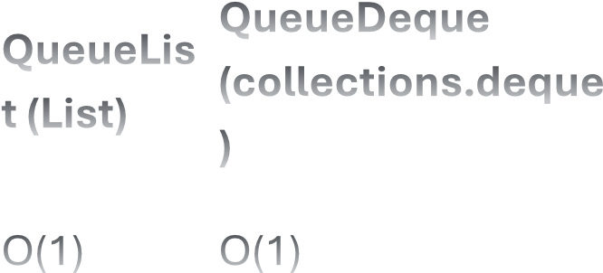**F~~e~~atu~~re~~ (collections.d~~e~~qu~~e~~**



**t (List)**

**)**

enqu~~eue~~() O(1) O(1) **QueueDeque**



**QueueLis**

**Feature (collections.deque**



**t (List)**

**)**

O(n)

dequeue() (due to O(1)



shifting)

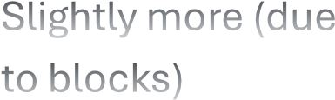Slightly more (due

Memory Overhead Low



to blocks)

Small queues,

High-performance,

Use Case Suitability low~~-~~



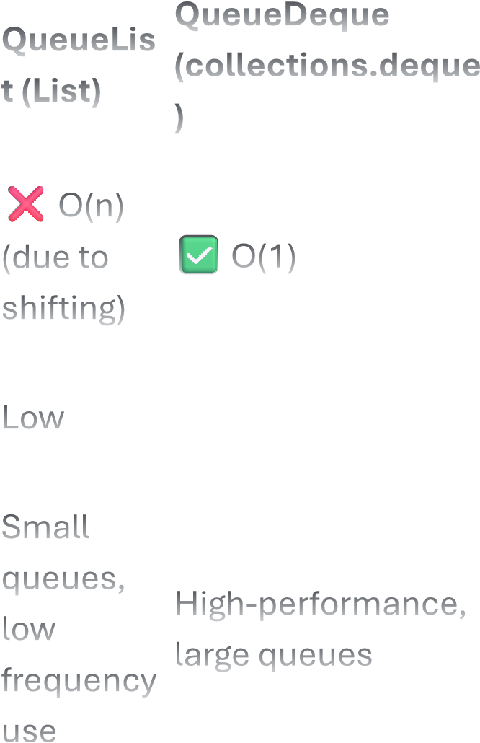large queues frequency use

Task-3:



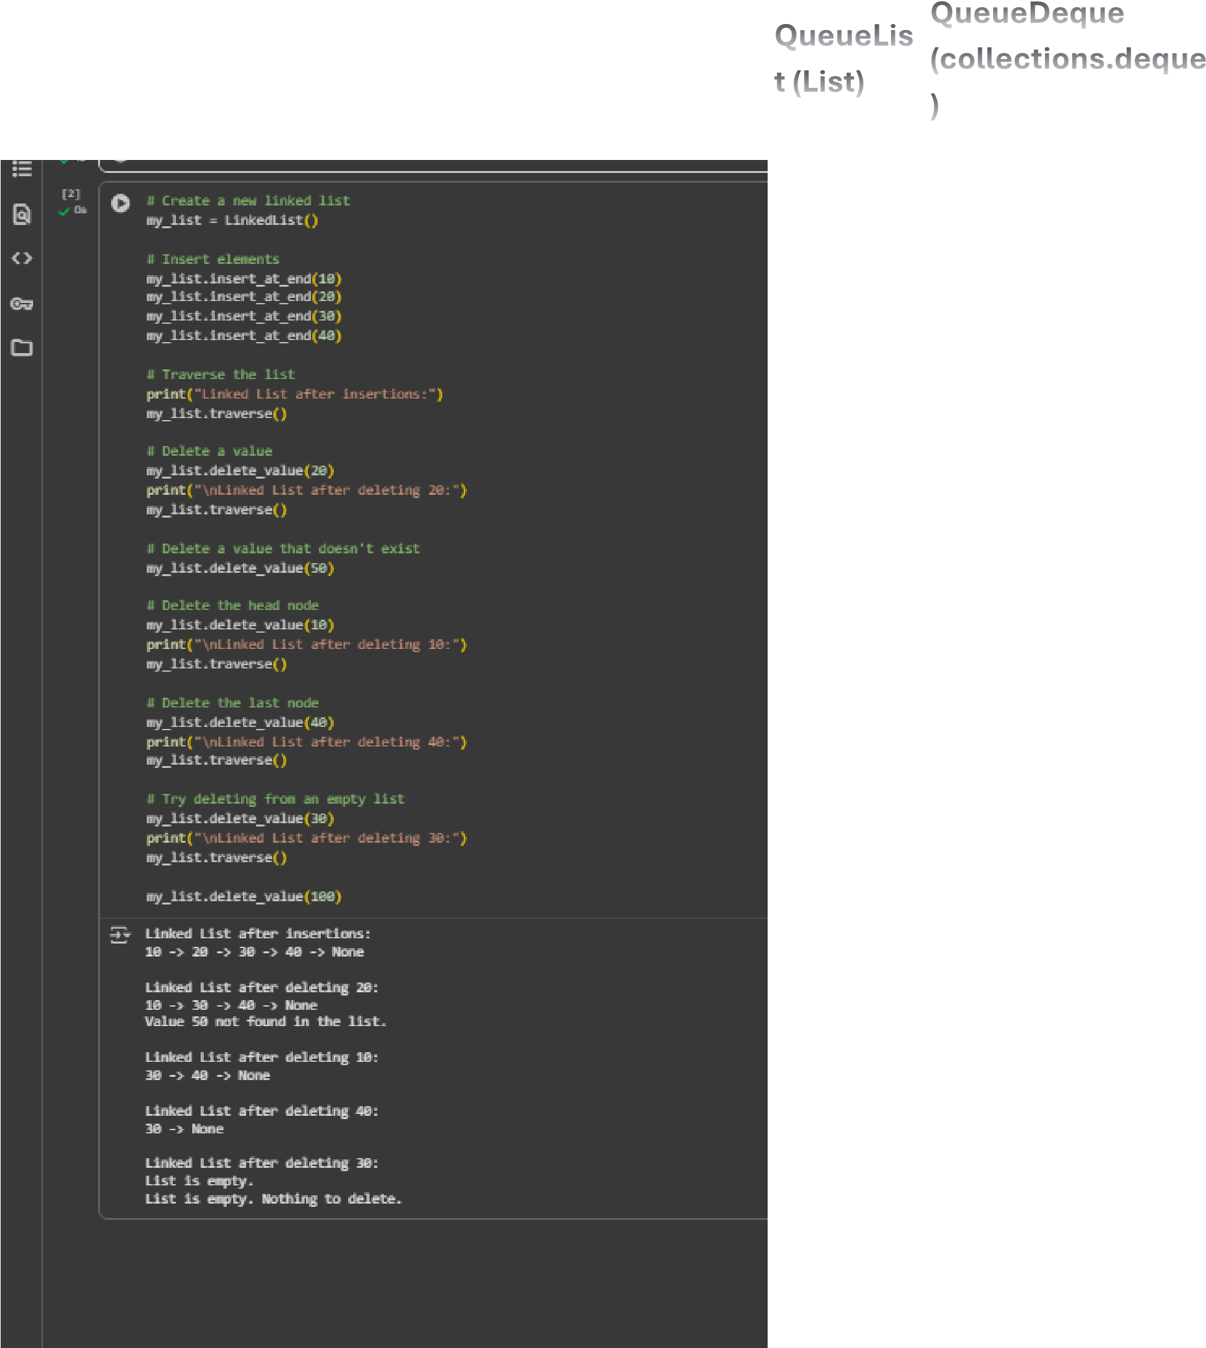Task-4:



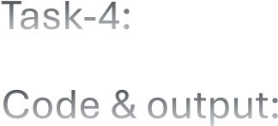Code & output:



